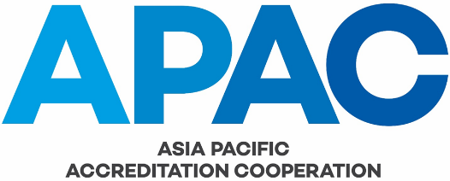

APPLICATION FORM FOR AFFILIATE STATUS

(Please type or write clearly in block letters)

On completion, applications should be forwarded to:

The Secretary
Asia Pacific Accreditation Cooperation
18 Ramsay Avenue
West Pymble
NSW 2073
Australia

email: secretariat@apac-accreditation.org

SECTION A

Name of Organisation in Full (English):

Name of Organisation in Full (Own Language):

Short Name/Acronym:

Address:

Country:
Telephone:
Facsimile:
Email:
Website:
Contact Person:
Position Within Organisation:

SECTION B

1. | Please describe the nature of the organisation’s business and how it relates to accreditation body activities.  Please also provide documentary evidence that the organisation is a legal entity, for example, certificate of incorporation, business registration certificate, etc.

2. | Describe the relationship, if any, that the organisation has with its domestic accreditation body/ies.

3. | Is the accreditation body part of a larger | Yes |  | No
 | organisation for example, Government Department or Ministry?

If “Yes”, please provide an organisation chart showing how the accreditation
body fits into the larger organisation (Please attach separately).

4. | Please include a description of how the organisation intends to participate in APAC’s activities.

Affiliate Application Declaration

I hereby declare that the organisation satisfies the requirements for Affiliate status and confirms its commitment to and support for the objectives of APAC.

I agree that, if this application is accepted by APAC, the organisation shall be bound by and at all times abide by the APAC Constitution and APAC Regulations and Codes.

(Name)
(please print)

(Position)

(Signature)

(Date)

