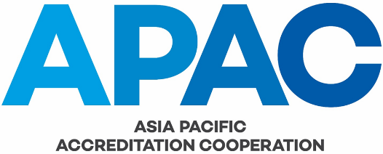

Checklist for Committee Chairs

Issue No. 1
Issue Date 1 January 2019
Application Date 1 January 2019

AUTHORSHIP
This document was produced by the APAC Executive Committee.

COPYRIGHT
Copyright in this document belongs to APAC. No part may be reproduced for commercial exploitation without the prior written consent of APAC.

FURTHER INFORMATION
For further information about APAC or this document, please contact the APAC Secretariat. Contact details can be found at www.apac-accreditation.org.

CONTENTS
1. PURPOSE 4
2. AMENDMENT TABLE 5

- PURPOSE
To assist APAC Committee Chairs in planning and performing their key responsibilities and tasks.
(Note: Timeframes for tasks may vary from time to time)

Item | When | Done
Provide a written committee report and current work plan for inclusion in the General Assembly agenda papers | 4 weeks prior to GA
Provide an itemised request for funding for the next year to be included in the draft APAC budget | 4 weeks prior to GA
Provide an electronic copy of the agenda papers for the committee meeting to the APAC Secretariat as well as to committee members | 4 weeks prior to meeting
Give permission or otherwise to requests for observers to attend the meeting | Ad-hoc basis prior to meeting
Appoint a minutes secretary for the meeting | Prior to meeting
Prepare and circulate an attendance list: minimum information to collect is name, affiliation (i.e. name of AB etc), and member/observer status | Prior to and at the beginning of meeting
Review terms of membership of committee members and maintain a record of date appointed/re-appointed | During meeting
Review activities and documents for which the committee is responsible and record the outcome in minutes of meeting | During meeting
Review the Terms of Reference; revise if necessary | During meeting
Review committee work plan and amend as necessary | During meeting
Prepare a short summary report to be presented at the General Assembly. Include proposed revision to Terms of Reference and Committee Work Plan | After meeting and prior to GA
Circulate completed draft minutes to members and append attendance list | 4 weeks after meeting
Send an electronic copy of the draft minutes to APAC Secretariat | 4 weeks after meeting
Provide final minutes from the previous meeting to the Secretariat | 4 weeks after meeting
Send an electronic copy of any revised Terms of Reference to APAC Secretariat | As necessary
Send changes of committee members to the APAC Secretariat to be added to the committee’s membership list | As necessary
Ensure the work plan is met | As necessary
Ensure APAC documents have been prepared or revised in accordance with APAC MS-001 Document and Records Control | As necessary
Provide a brief report, including a list of any sub-committees and working groups and the names of their convenors, and a current membership list, for inclusion in the agenda papers for the mid-term Executive Committee meeting agenda papers | 4 weeks prior to mid-term Executive Committee meeting
Upon receipt of the work plan from the Secretariat, the Committee Chairs shall provide an updated committee work plan to the Secretariat prior to Executive Committee meetings | 4 weeks prior to the mid-term Executive Committee meeting

- AMENDMENT TABLE
This table provides a summary of the changes to the document with this issue.
Section(s) | Amendment(s)
All | New issue on establishment of APAC. Document transposed from APLAC SEC 101 Checklist for Committee Chairs Issue No 1
End

