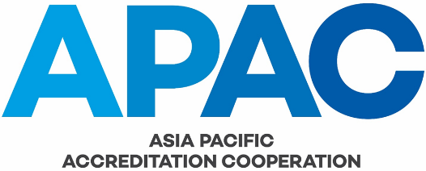

Evaluator Training Course – Participant Evaluation Form

Participant (name): |  |  |  | Accreditation Body:
Location: |  |  | Date:

Check Here | To Be Completed for Each Participant by Facilitators |  | Worth | Score
 | Course Preparation:
 | The Participant was not prepared and had not read the material |  | 1
 | The Participant was marginally prepared and had read some of the material |  | 2
 | The Participant was mostly prepared and had read most of the material |  | 3
 | The Participant was very well prepared and had read all of the material |  | 4
 | The Participant was extremely well prepared and had examined outside material |  | 5
Understanding of Evaluation Concepts:
(MRA evaluation philosophy, understanding and application of evaluation criteria, ability to formulate and articulate findings)
 | The Participant did not demonstrate any understanding of evaluation concepts |  | 1
 | The Participant demonstrated marginal understanding of evaluation concepts |  | 2
 | The Participant demonstrated appropriate understanding of evaluation concepts |  | 3
 | The Participant demonstrated excellent understanding of evaluation concepts |  | 4
 | The Participant demonstrated complete understanding evaluation concepts |  | 5
 | Participation:
 | The Participant did not participate in discussion with their peers. |  | 1
 | The Participant participated somewhat in discussion with their peers. |  | 2
 | The Participant participated in discussion with their peers. |  | 3
 | The Participant participated very effectively in discussion with their peers. |  | 4
 | The Participant made significant contribution to the success of their group. |  | 5
 | Teamwork:
 | The Participant did not demonstrate an ability to work with their peers. |  | 1
 | The Participant demonstrated some ability to work with their peers. |  | 2
 | The Participant demonstrated appropriate ability to work with their peers. |  | 3
 | The Participant was at ease in working with their peers. |  | 4
 | The Participant placed the success of their team foremost in their own approach. |  | 5
Overall Score (Pass = 12)

TRAINING COURSE FACILITATOR’S COMMENTS

(Facilitator Name: )

