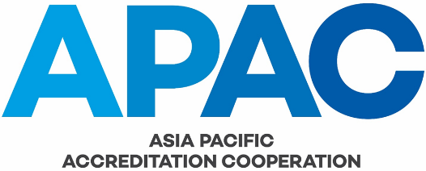

NOMINATION OF APAC REPRESENTATIVES TO THE IAF MLA OR ILAC ARRANGEMENT MANAGEMENT COMMITTEE

The following process shall be used by the APAC MRA Management Committee to nominate members for service on the IAF MLA Management Committee or the ILAC Arrangement Management Committee.

- Chair of the MRA Management Committee advises all Members the MRA Council of the vacancy and calls for nominations. The nomination period is 30 days, however the Chair of the MRA Management Committee may shorten this period to 15 days if necessary;
- Nominated candidates must have experience managing operational activities within an AB;
- The Chair of the MRA Management Committee contacts nominees for confirmation that they are able to accept the position and to allocate sufficient time/resources to it if they are elected;
- The Chair of the MRA Management Committee prepares a voting ballot noting the name of the relevant committee and the names of nominees;
- MRA Council members have a 30-day period to vote (may be reduced to 15 days if an unexpected vacancy occurs);
- Nominees are elected by a simple majority (over 50% of the vote);
- At the end of the ballot period, if three fourths of the members have voted, the Chair advises the result to the MRA Council and the APAC Executive Committee;
- The MRA Management Committee Chair advises IAF or ILAC as appropriate of the successful candidate.

