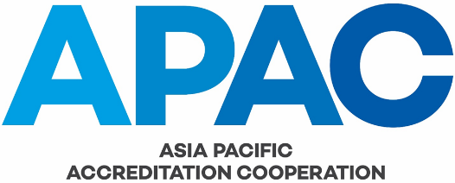

Evaluation Report Review Checklist

Activities | Yes/No | Remarks
Step 1. Establishing whether the findings are reliable
With reference to the evaluation schedule, was sufficient time allocated to different evaluation activities (team meetings, AB office evaluation, assessment witnessing, exit briefings)?

Was the number and type of assessments witnessed appropriate to the range of accreditation activities covered by the AB’s (proposed) MRA recognition?

Were the major and/or critical fields of activity subject to appropriate witnessing?

Does the evaluation report contain sufficient evidence that the evaluation team has conducted an evaluation of the AB against the criteria to sufficient depth?

Were the findings (Nonconformities and Concerns) detailed in Annex I of the evaluation report supported by objective evidence (detailed either with the finding or in the main body of the report)?

Based on the evidence,
  - Were the findings correctly classified in accordance with the classification given in IAF/ILAC A-3 Part 3 B?
  - Were they correctly referenced against the MRA criteria?
  - Were these references valid?
  - Where necessary, was the interpretation of criteria adequately explained?

Step 2. Establishing whether the actions taken by the AB to address the findings are effective
Has the AB accepted the findings?

In the case of nonconformities,
Has the AB identified the root cause?
Has the AB fully addressed the nonconformity, or as fully as is possible?

In cases where time is required to fully address the root causes of nonconformities:
Has sufficient progress been made?
Has a reasonable timeframe for completion been defined?

In the case of concerns
Has the AB identified the root cause?
Has the AB defined a reasonable action plan to address the identified issue?

Has the evaluation team evaluated the corrective actions and response from the AB in sufficient detail?

Is the outcome of this examination (as conveyed to the AB) acceptable?

(When drawing conclusions on the acceptability of the outcome, the MRA Council delegate should recognise that (s)he may not have full knowledge of the supporting evidence provided by the AB. The MRA Council delegate may therefore need to seek clarification before drawing a conclusion.)

Step 3. Establishing whether the conclusions are substantiated by the findings
Has the report in its entirety provided sufficient evidence to support the conclusions and recommendations of the team? The scope and nature of any or all of the findings and the corrective actions taken by the AB should be taken into consideration.

Has the evaluation provided adequate evidence that the CABs accredited by the AB are technically competent and capable of being recognised under the MRA?

Step 4. Establishing whether the team’s recommendations are substantiated by the conclusions
Is the recommendation of the team with regard to entry/continuation in the MRA consistent with the conclusions made by the team and acceptable to the MRA Council?

Does the recommendation of the team with regard to the re-evaluation time frame reflect the current status of the AB? Issues to consider include:
- The nature of the findings from the evaluation and the status of their closure;
- The maturity of the AB’s accreditation programs (proposed to be) covered by the MRA;
- The relative stability of the AB;
- Whether the AB and its accredited CABs pose a risk to the MRA;
- The precedents established by the Council when deliberating similar cases in the past.

