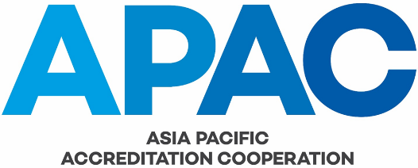

COMMITTEE WORK PLAN TEMPLATE

In accordance with APAC GOV-004, each committee must establish and maintain a comprehensive work plan that is aligned with APAC’s Strategic Plan. The work plan must identify specific committee activities and include a schedule for the review of the APAC documents for which the committee is responsible. The following template is to be used for reporting to the APAC General Assembly and Executive Committee.

20<XY> WORK PLAN - APAC <ABC> COMMITTEE
Date proposed | Proposed  by | Brief description of activity | APAC Strategy | APAC funding required  (AUD) | Deliverable(s) | Expected  completion  date | Date approved by APAC GA | Status & status date

