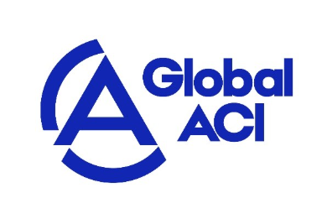

GLOBAL ACCREDITATION COOPERATION INCORPORATED
MRA DECLARATION FOR LEVEL 4 OR LEVEL 5 NORMATIVE DOCUMENTS UNDER CATEGORY 2 FOR ACCREDITATION BODY

Issue Date: 14 May 2026
Implementation Date: 14 May 2026
Version No: 2.0

- Accreditation Body’s name: to be filled in

- Accreditation Body’s address: to be filled in

- Object of the declaration:

We herewith as signatory to the Global Accreditation Cooperation Incorporated (Global ACI) MRA for the main scope: scope level 2 based on standard level 3 declare that we have extended our service to include list the Level 4 or Level 5 Normative Documents under Category 2.
The extension has been executed using the process for the extension of the scope of our AB as described in our management system, which was evaluated and accepted by the Global ACI following our last peer evaluation.
The requirement documents associated with the scope extension are listed at item 4 below.

- The object of the declaration described above is in conformity with the requirements of the following documents (please refer to Global ACI normative documents in force on FMRA-001 Structure and Normative Documents under the Scope of Global ACI MRA):

Accreditation Body Requirement documents (if applicable):
to be filled in

Conformity Assessment Body requirements:
to be filled in

Certification Standard:
to be filled in

5. Additional information:

Number of CABs accredited for the extended Level 4 or Level 5 Normative Documents under Category 2: | to be filled in

other relevant information to be filled in

Signed for and on behalf of:

……………………………………………………………………………

.........................................................................................................
(Place and date of issue)

.................................................. ......................................................
(Name, function) (Signature or equivalent authorised by the issuer)

One form for each Level 4 or Level 5 Normative Documents under Category 2.

